Kohonen Self Organizing Map (KSOM)
- A self-Organizing Map (SOM) varies from typical artificial neural networks (ANNs) both in its architecture and algorithmic properties.
- Its structure consists of a single layer linear 2D grid of neurons, rather than a series of layers.
- 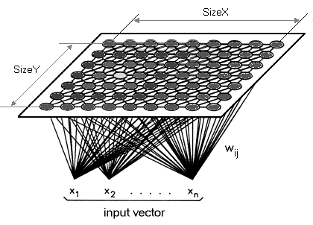
- All the nodes on this lattice are associated directly to the input vector, but not to each other.
- It means the nodes don't know the values of their neighbors, and only update the weight of their associations as a function of the given input.
- The grid itself is the map that coordinates itself at each iteration as a function of the input data. As such, after clustering, each node has its own coordinate (i,j), which enables one to calculate Euclidean distance between two nodes by means of the Pythagoras theorem.
- A Self-Organizing Map utilizes competitive learning instead of error-correction learning, to modify its weights.
- It implies that only an individual node is activated at each cycle in which the features of an occurrence of the input vector are introduced to the neural network, as all nodes compete for the privilege to respond to the input.
- The selected node- the Best Matching Unit (BMU) is selected according to the similarity between the current input values and all the other nodes in the network.
- Kohonen Self-Organizing feature map (SOM) refers to a neural network, which is trained using competitive learning.
- Basic competitive learning implies that the competition process takes place before the cycle of learning.
The competition process suggests that some criteria select a winning processing element. After the winning processing element is selected, its weight vector is adjusted according to the used learning law.

